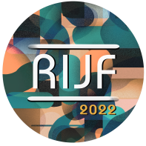
RHODES AND SOUTH AEGEAN INTERNATIONAL JAZZ FESTIVAL
“Jazz Across The Water"
SAVE THE DATE
2022, August 27 - 30 @ Rhodes island

For the fourth year, the island of the Knights will be flooded with jazz melodies, at the Rhodes & South Aegean International Jazz Festival, a great celebration that will take place this year at the impressive Palace of the Knights and the Ancient Odeon of Rhodes. The festival's artistic director is Dimitrios Vassilakis, an internationally renowned saxophonist, composer, and academic researcher.This year's festival will take place from 27 to 30 August (Website. Youtube channel).

The festival is co-organized by the Rhodes Municipality Organisation of Culture & Sports - DOPAR, the Prefecture of the South Aegean, Jazz Democracy NPO, and under the auspices and support of the Greek Ministry of Culture and Sports.
Saturday August 27th @ Cine Rodon
Candid Stories Panel; Women in jazz / Jack Kerouac 100th birthday / Jazz in the movies

Sunday August 28th @ Grand Palace of the Knights of Rhodes
Marios Charalambous quartet | Cyprus
Shekinah Rotz quartet featuring Inbar Fridman and Olivier Gatto | Puerto Rico, France, Israel, Greece, Rhodes
Monday August 29th @ Grand Palace of the Knights of Rhodes
Doc In Absolute Trio | Luxemburg
Tanini Trio, sisterhood with Bodrum Jazz Festival | Turkey
Jam session. A collaboration of Turkish, Greek and Cypriot musicians on stage.

Tuesday August 30th @ Odeion of Rhodes Ancient Acropolis, Rhodes
Maria Manousaki group | Greece, Crete
Craig Bailey with Dimitrios Vassilakis Arthenian Quartet Ballads & Blues with special guests Nefeli Fasouli, Nestor Vassilakis and Lefteris Chatziantonis | USA, Athens University, Cincinnati University, Greece, Rhodes
Free entrance events @ 9pm, doors @ 8:30pm
You will find the program of the festival and all its parallel activities on its official website.

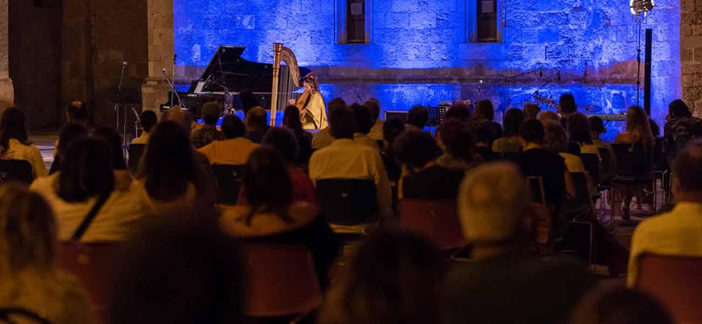
RIJF 2021, Grand Palace of the Knights of Rhodes ⓒ v. hatzikelis photography
Co-organized by DOPAR, the Region of South Aegean and Jazz Democracy, with the auspices and support of the Ministry of Culture & Sports. This year the festival is under the auspices of the Ministry of Maritime Affairs & Insular Policy, under the auspices and support of the General Secretariat for the Aegean & Insular Policy, under the auspices of Ministry of Tourism and the National Tourism Organisation and under the auspices of National Kapodistrian University of Athens. With the support of the Embassy of Israel, Arts Council Luxembourg, Ministry of Culture of Cyprus. With the participation of the International Writers' & Translators' Centre of Rhodes. Significant international promotion by Redwood Entertainment in New York.

Saturday August 27th
9pm (free entrance)
@ Cine Rodon

Candid Stories Panel
Women in jazz / Jack Kerouac 100th birthday / jazz in the movies

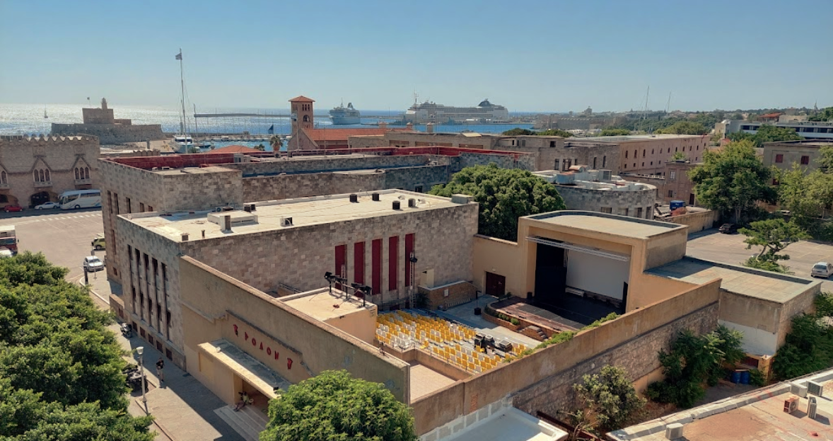

A panel in collaboration with the International Writers and Translators Centre of Rhodes. An evening that will be structured in 3 parts: 1. Jazz democracy and the voice of women, 2. Jack Kerouac 100th birthday and 3. The screening of a short jazz documentary.

On the panel we will host George Ikaros Babasakis distinguished writer and translator, Dimitrios Vassilakis artistic director, saxophonist, composer and poet, Shekinah Rotz saxophonist, flautist and composer from Puerto Rico, Inbar Fridman guitarist from Israel, Vasilis Mantikos writer from Rhodes. We will host online Maria Manousaki, violin player from Crete and Nefeli Fasouli vocalist, both important artists of this year's festival.

Sunday August 28th
9pm (doors open 8:30pm free event)
@ Grand Palace of the Knights, Rhodes
9pm. Marios Charalambous quartet (Cyprus)
with Marios Charalambous (tenor sax), Andreas Panteli (piano), Michail Ermis (guitar), Kyriakos Kesta (bass), Omiros Miltiadous (drums)

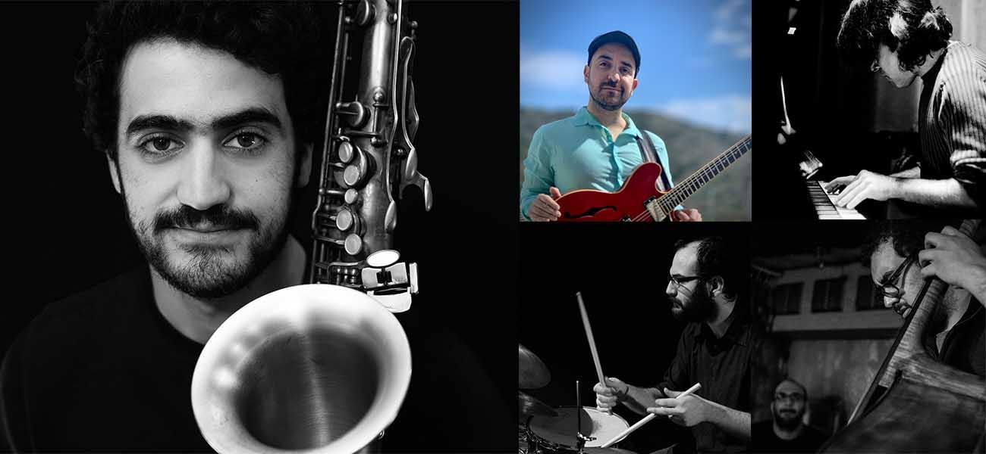

The band will present original compositions in the modern jazz style, influenced by the modal period of John Coltrane and modern developments like Kenny Garrett, Ben Wendel and many others. Marios Charalambous is a young upcoming Cypriot saxophonist and composer studying at the Amsterdam Conservatory and recipient of Nicolas Economou Foundation - NEF scholarship. He has appeared at international festivals and venues in Cyprus, Holland, Belgium, France and Italy. He tours with his quintet presenting original material.
Marios Charalampous Quartet - Oddyseia | Marios Charalampous Quartet - Answering

10pm. Shekinah Rotz Quartet featuring Inbar Fridman and Olivier Gatto
(Puerto Rico, France, Israel, Greece Rhodes)
with Shekinah Rotz (saxophones, flute, vocals), Inbar Fridman (guitar), Manos Saridakis (piano), Olivier Gatto (bass), Aris Solomon (drums)

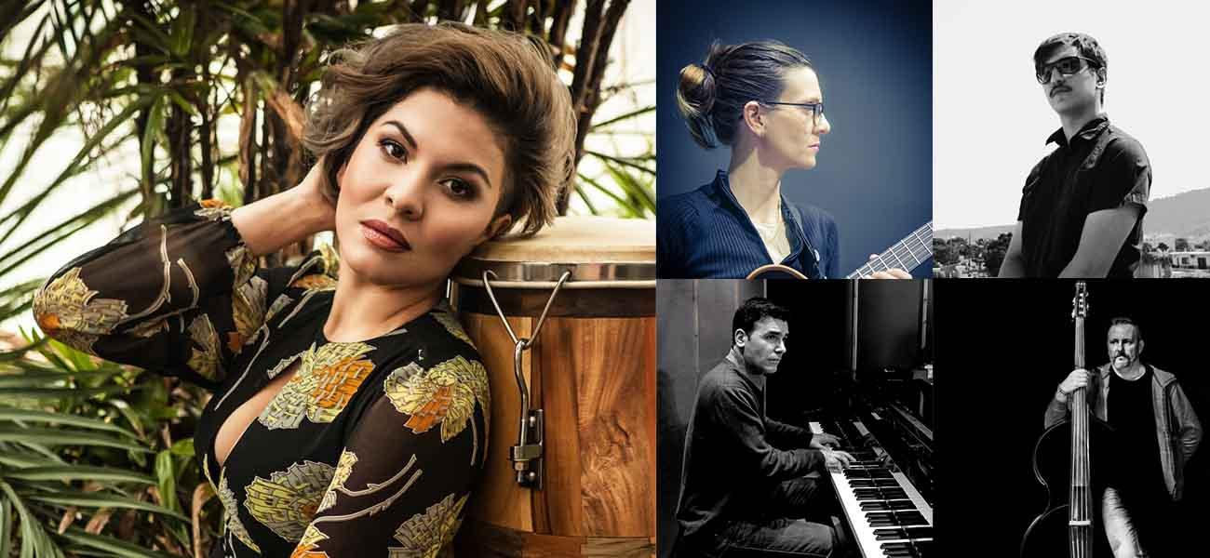

One of the strongest female voices in contemporary jazz, saxophonist, flautist and composer Shekinah Rotz from Puerto Rico will present original music from her projects with “Spiritual Warriors Orchestra” plus music from John Coltrane, Yusef Lateef, Kenny Garrett, Cannonball Adderley, Ahmad Jamal. She has lived and studied in Puerto Rico, US and France, and has performed at jazz festivals and special concerts in England, Switzerland, Israel, France, Greece, Spain and Martinique, as well as in the United States with stellar musicians as Nicholas Payton, Bill Stewart, Terreon Gully, Kamau Daáood, Sam Newsome, Meg Okura.

Olivier Gatto on the double bass, an influential bass player and composer from France and Inbar Fridman, a top guitarist from Israel. On the piano one of the most prominent Greek pianists Manos Saridakis and Aris Solomon on drums, a young player from the island of Rhodes.
Spiritual Warriors Orchestra - Belize | Shekinah Rotz Quintet - Youtube | Inbar Fridman - Website | Olivier Gatto - Facebook

Monday August 29th
9pm (doors open 8:30pm free event)
@ Grand Palace of the Knights, Rhodes

9pm. Dock In Absolute Trio (Luxembourg)
with Jean Philippe Koch (piano), Victor Kraus (bass), Arne Wiegand (drums)

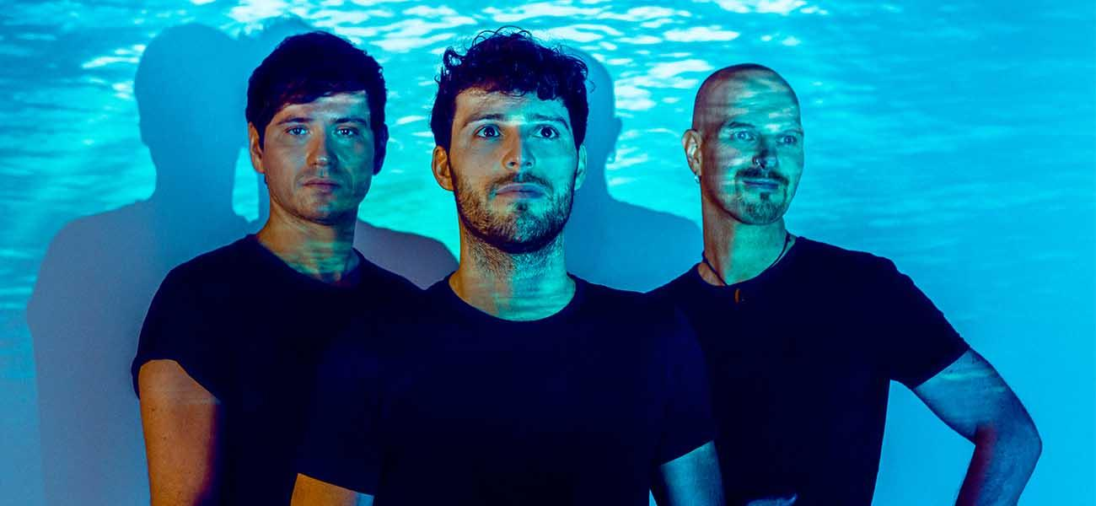
Dock In Absolute is a piano trio led by pianist Jean Philippe Koch from Luxembourg, that combines different styles of progressive Jazz, classical and rock. DIA has been named the “Export Artist of the Year 2017 and 2019” by music:LX as a result of being the most active band in Luxembourg and discovery artist of the year by Jazznews. Their latest album belongs to the "100 Greatest Albums of the year" by the Jazzit Magazine Awards.
Dock In Absolute’s music is sparkling, varying, forceful, pressing, rich in twists and turns in mood: from lyrical to unrestrainable, from wild to graceful, from virtuosic and crystalline to assertive and dramatic, from subdued to airy and demonstrative. At the RIJF, the band will perform songs from their first and second album as well as new material.
Dock In Absolute - Website | Doc In Absolute - Youtube | Doc In Absolute - Spotify

10pm. Tanini Trio (Turkey, as part of the sisterhood of RIJF with Bodrum Jazz Festival)
with Tahir Aydoğdu (qanun), Burçin Büke (piano), Bilgin Canaz (ney or reed flute)
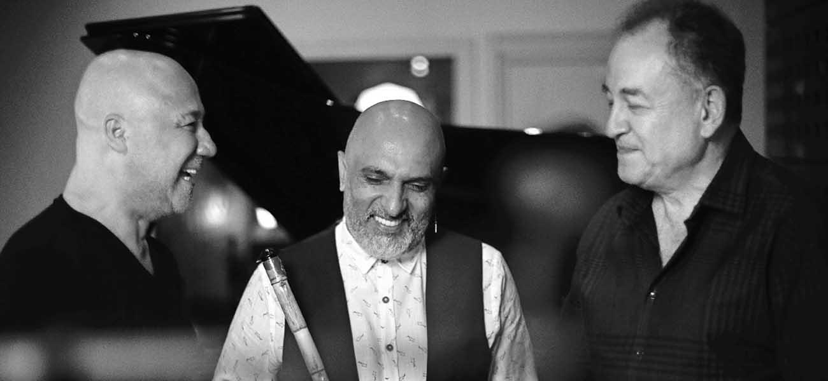

The Tanini Trio consists of three virtuoso musicians, each of whom has a successful international career in his own right. They have a select repertoire, consisting of Western music with Turkish elements and Turkish music with Western elements. They sensitively blend traditional Turkish and Western melodies with jazz, thus creating bridges between different cultures.

They have performed in Turkey, Italy, Germany, Germany, USA, South Korea, Canada, Bulgaria, Hungary, Lithuania, Turkmenistan, Spain, Malta, Poland, England, Scotland, Bosnia-Herzegovina, Taiwan, Malaysia, Cyprus, Cyprus and Jordan. They have recorded two albums, Dokunuşlar (Touches) and Dokunuşlar II (Touches II).
Tanini Trio -Youtube, Tanini Trio - Spotify

Tuesday August 30th
9pm (doors open 8:30pm free event)
@ Odeion of Rhodes Ancient Acropolis, Rhodes

9pm. Maria Manousaki Group (Crete, Greece)
with Maria Manousaki (violin), Dimitris Verdinoglou (piano), Michalis Evdemon (bass), Alekos Roupas (percussion)

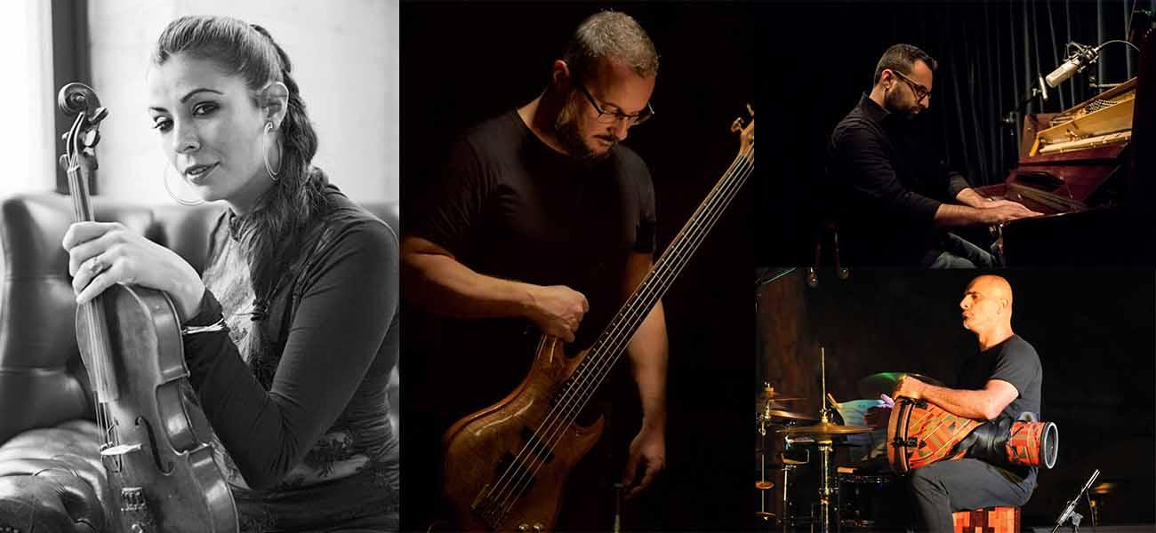

Maria Manousaki stands as one of Greece’s most successful and versatile musical talents, working to great acclaim and commercial success as a violin performer, band leader and festival organiser. She was born in Johannesburg and divides her time between the island of Crete and New York. Her music is inspired by her Cretan roots and her love for jazz. She often performs as a soloist and has released two albums: "Sole Voyage" (winner of the best jazz album at the “Academia Awards” in 2016) and “Hidden Trails”.

Maria is the founder of The Cretan World Music Festival which was initiated in Chania Crete in July 2014. Since 2018, she is the musical curator for the Vlatos Jazz in the island of Crete, a series taking place in a relic of an unused stone church built in 1855.

Maria Manousaki - Website | Maria Manousaki - SOLE VOYAGE | Maria Manousaki - Hidden Trail

10pm. Craig Bailey with Dimitrios Vassilakis Arthenian Quartet (Ballads & Blues)
with special guests Nefeli Fasouli, Nestor Vassilakis, Eleftherios Chatziantonis (USA, Athens University, Cincinnati University, Greece Rhodes)
with Craig Bailey (alto sax), Dimitrios Vassilakis (saxes, vocals), Nefeli Fasouli (vocals), Nestor Vassilakis (tenor sax), Eleftherios Chatziantonis (tenor sax), Emmanuel Saridakis (piano, keyboards), Manos Loutas (bass), George Polyhronakos (drums)

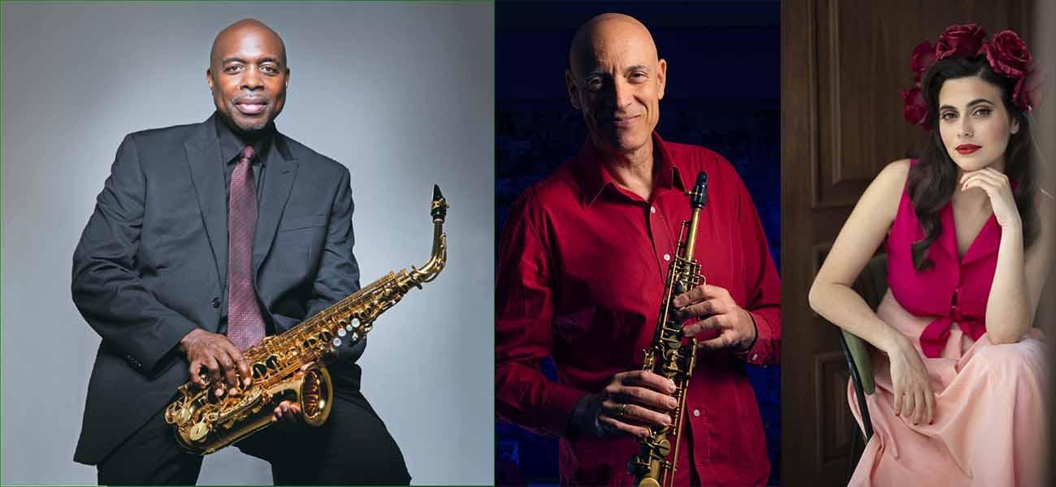
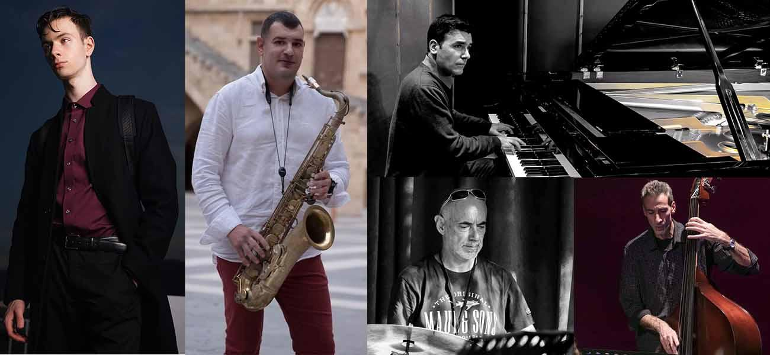

Long time friends and Candid artists Craig and Dimitrios present a selection of blues and ballads from their award-winning Candid records discography. A soulful blues style with a mixture of post bop and modal music approach. An ongoing project to showcase the energy and impact of the blues and the emotional power of ballads.

Craig Bailey is a New York jazz saxophonist, clarinettist, flautist and composer who became Ray Charles’ lead alto saxophonist and arranger from 1988 until 2004. His debut album, A New Journey, was met with critical acclaim, and is referenced in "The Encyclopaedia of Jazz" (revised by Ira Gitler).. Bailey's other albums releases include: Brooklyn Big Band Live at Sweet Rhythm (2009) and Music à la Fleek as Craig Bailey and The Ohio Jazz Players (October 2018).Bailey joined the University of Cincinnati - College Conservatory of Music serving as the Associate Professor in Jazz Saxophone studies while still playing music throughout the country and abroad.
Dimitrios Vassilakis an internationally acclaimed Greek saxophonist, vocalist, composer and educator with 4 award-winning albums for historic jazz label Candid Records. Founder and Artistic Director of Rhodes & South Aegean International Jazz Festival and Jazz Democracy with presentations at Dizzy’ s Club - Jazz at The Lincoln Center, Birdland, Yale, Smithsonian Institute, London Jazz Festival Ronnie Scott’s and major festivals. Has taught at Yale, Queens, Skidmore, Columbia, DePaul, Georgia Tech, Paris Conservatoire, Singularity, Aristotle and Macedonia Universities, and since 2017 is a researcher and adjunct faculty at the Athens Kapodistrian University. Presented his concept “Jazz Democracy” at the United Nations New York for International Jazz Day 2018.

press:
“Infinite grace poetry and passion”
“Greek saxophone prodigy Dimitri Vassilakis is revered as the Hellenic god of postmodern expression. A rhapsodic stylist of immense power and authority.”
BBC Music Magazine (album of the month, voted 2nd jazz album of the year)

“Leader Vassilakis’ compositions offer a perfect platform for post-modern expression…whiz-kid tenor player from Greece…his style is the post-Coltrane, post-Rollins style…high-energy and immensely fluid.’’
New York Press (Labyrinth Live at Birdland)

Craig Bailey - Website | Craig Bailey - Cherokee | Dimitri Vassilakis - Website | Dimitri Vassilakis - Jazz Democracy - TEDxAthens | Dimitri Vassilakis - Youtube | Nefeli Fasouli- By any chance

Festival Team
Founder - Artistic Director: Dimitrios Vassilakis
Vice President Jazz Democracy, Administration, Communication, Directorate of Educational Programmes: Elena Michailou
Coordination, Communication: Danai Tezapsidou
Network management and development in Greece: Penelope Giannakopoulou
Coordination in Rhodes: Eleftherios Chatziantonis
Social Media: Georgia Theodosiou
Public Relations & Communication: Vaso Sotiriou
Management responsible, International Public Relations & Communication: Redwood Entertainment
Graphic Design: Aris Solomon
Photography, video: Vangelis Hatzikelis
Website: Nikos Tsirigotis
Trailer Editor: Dotmov
Sound and light engineering: Giorgos Axarlis

Auspices - Support - Collaborators - Sponsors

Co-organized by DOPAR, the Region of South Aegean and Jazz Democracy, with the auspices and support of the Greek Ministry of Culture & Sports. This year the festival is also under the auspices of the Greek Ministry of Maritime Affairs & Insular Policy, under the auspices and support of the General Secretariat for the Aegean & Insular Policy, under the auspices of the Greek Ministry of Tourism and the Greek National Tourism Organisation and under the auspices of National & Kapodistrian University of Athens. With the support of the Embassy of Israel in Greece, the Arts Council Luxembourg and the Cyprus Ministry of Education Sport and Youth. With the participation of the International Writers' & Translators' Centre of Rhodes. International promotion by Redwood Entertainment New York.

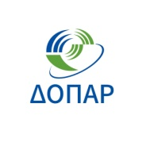
Transportation sponsor: Blue Star Ferries. Hospitality sponsors: Apollo Blue Hotel, Apollo Beach Hotel, Hermes Hotel, 10GR Hotel, Rodos Palace Hotel, Plaza Hotel, Cook’s Club.
Services sponsors: Café Auvergne, Travel Exchange, Rodos Cars, Xenakis Cars.
Communication sponsors: Melodia FM, Pepper Radio, Fantasia.
“Jazz Across the Water” Sisterhood with Bodrum Jazz Festival.
International PR: Redwood Entertainment New York.
Affiliated festivals and institutions: Syros Jazz Festival, Mykonos Music Festival, Rhodes Summer Festival, Koulias Group, Armonia Music School Kos.
CO ORGANISED BY :
